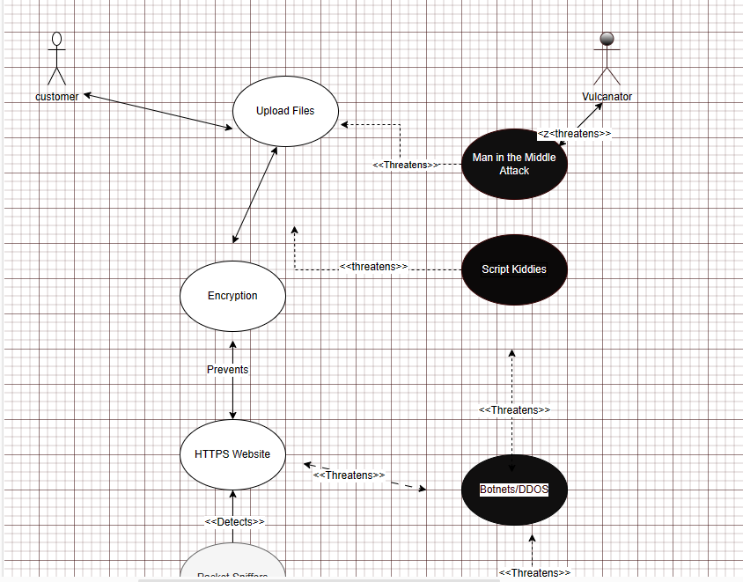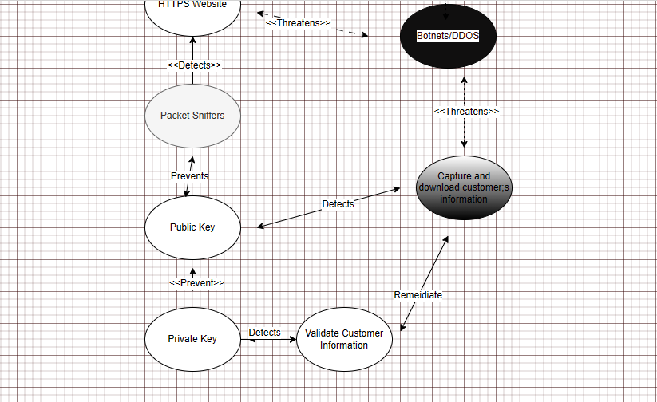

Link to aptio: [customer v7.drawio - draw.io (diagrams.net)](https://app.diagrams.net/)